Government and Community Services (GCS) is a proactive outreach arm of the County. GCS focuses on facilitating improved community outreach, administration of government services, and the resolution of community issues. GCS recognizes an “Organization of the Month” that exemplifies the importance of supporting the community and assisting in getting resources to those most in need. This month’s organization of the month is FoodShare SC. GCS had the opportunity to tour their Richland County Hub and the site of a new teaching kitchen at 201 Columbia Mall Blvd Suite 109 in the County’s Northeast community. Additionally, FoodShare SC utilizes volunteers to pack their food boxes and Kim Humphrey, GCS Relations Associate, provided assistance at a recent packing day. To volunteer or gain more information about FoodShare SC contact the information listed below.

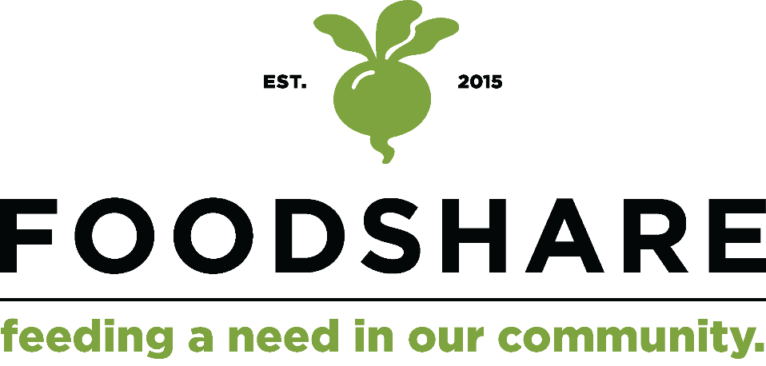
why we do what we do
Many communities in South Carolina do not have access or financial resources to eat healthy daily. Barriers include where people live, age, income, and whether reliable transportation exists. Without healthy options, health risks increase. Bringing fresh produce into our communities is a form of food equity and is part of our mission. FoodShare's goal is to enhance the quality of life in our diverse communities by increasing access to fresh, affordable produce and providing quality cooking skills education.
WhO WE REACH
Founded in April 2015, FoodShare South Carolina has distributed nearly 84,000 Fresh Food Boxes from the main hub of operation in Richland County through June 2022. Working with additional non-profits across the state, FoodShare now operates distribution hubs in nineteen South Carolina counties to serve primarily rural communities.
To date, these hubs have sold & distributed more than 230,000 Fresh Food Boxes containing over 4 million pounds of produce, with more than 60% of the boxes purchased by SNAP EBT or provided to families using additional grants and donations. In 2019, FoodShare was recognized as an emerging evidenced-based intervention to improve food access by the USDA’s Food and Nutrition Service and SNAP-ED program.
HOW WE SERVE
We envision a food system that nourishes all people in our State. South Carolina has a wealth of knowledgeable partners and organizations on which to draw upon as well as the experience to address the challenges that our communities are facing. We are partnering with our current member hubs as well as broader partners to address root causes of limited food accessibility and the lack of nutrition education.
In a state where diet-related chronic illness is so widely prevalent, we are making fresh produce and nutrition education a priority for our community.
OUR PROGRAMS
THE FRESH FOOD BOX
The Fresh Food Box contains 9-11 varieties of top-quality fruits and vegetables. Unique recipes, tips and nutrition notes are included in each box to give participants the encouragement to expand their knowledge, cook new things and eat healthier. The Fresh Food Box is priced to be affordable for lower-income families, primarily those receiving SNAP benefits. Leveraging the Healthy Bucks program administered through the South Carolina Department of Social Services, families receive up to three times the cost of their purchase of fruits and vegetables when purchasing using SNAP/EBT.
VEGGIERX
VeggieRx is a fruit and vegetable prescription program designed to increase the intake of fresh produce for patients with diet-related diseases to improve health outcomes (measured in reduced A1C, blood pressure and weight levels).
CULINARY MEDICINE
Our Culinary Medicine program teaches nutrition science and culinary skills to medical learners and professionals at the University of South Carolina Columbia School of Medicine using a nationally accredited curriculum to help practitioners prescribe “food as medicine.”
NEIGHBORSHARE
NeighborShare connects people who lack transportation with volunteers who deliver Fresh Food Boxes directly to them.
COMMUNITY COOKS
Our Community Cooks classes are for anyone interested in gaining kitchen confidence, addressing their health through daily meal choices, or changing their diet because of a recent diagnosis. The classes are supportive of behavior change and understanding recipes to replicate at home.
FOR MORE INFORMATION
Website: www.foodsharesc.org
Phone: 803-851-4461
Email: info@foodsharesc.org
FoodShare South Carolina is a program of the University of South Carolina School of Medicine Columbia.

